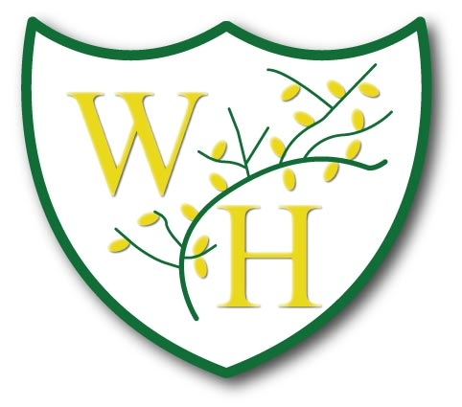

Key Vocabulary
PSHE and Wellbeing
Key
Green Highlighted Text | Repeated twice
Red Highlighted Text | Repeated three times
Blue Highlighted Text | Repeated four times
Purple Highlighted Text | Repeated five or more times

PSHE Vocabulary
Year 1
Relationships | Living in the Wider World | Health and Wellbeing
family, belong, same, different, friends, relatives, friendship, qualities, caring, sharing, like, dislike, help, feelings, confidence, praise, proud, relationships, special, appreciate, grow, secrets, private, private parts, touch, uncomfortable, permission, respect, polite | Safe, similarity, same as, different from, difference, bullying, celebrations, special, unique, special, belonging, special, rights, strengths, responsibilities, rewards, proud, community, upset, worried, online, computing, e-safety, digital devices, communicate, rules, permission, age restrictions, community, jobs | healthy, unhealthy, balanced, exercise, sleep, clean, balanced, safe, sun protection, keeping clean, hygienic, safe, safety, medicines, proud, success, achievement, goal, goal, learning, working together, team work, celebrate, learning, challenge, feelings, overcome, achieve, dreams, anxious, worried, excited, male, female, body parts, private parts, growing-up, changing, environment, recycling
Year 2
Relationships | Living in the Wider World | Health and Wellbeing
family, friends, belong, same, different, lonely, friendship, qualities, honesty, caring, sharing, cooperation, kind, pressure, behaviour, dislike, help, helpful, community, feelings, confidence, praise, skills, self-belief, incredible, proud, celebrate, relationships, special, appreciate, changes, life cycles, baby, adult, adulthood, grown-up, mature, | safe, unsafe, familiar, unfamiliar, responsibilities, danger, medicines, emergency, emergency services, risk, internet, e-safety, factual, true, untrue, money, electronic payments, needs, wants, choices | healthy, unhealthy, physical health, mental health, medicines, vaccinations, allergies, routines, balanced, exercise, sleep, choices, clean, keeping clean, hygienic, feelings, mood, anxious, worried, excited, life cycle, trust, safe, male, female, vulva, vagina, penis, testicles, responsibilities, goals, community, included, similarities, differences
Year 3
Relationships | Living in the Wider World | Health and Wellbeing
Single parents, same-sex parents, step-parents, blended families, foster care, adoptive parents, birth, uterus, growing up, support, stability, responsibilities, respect, differences, similarities, conflict, solution, problem-solving, internet, social media, online, risky, gaming, safe, unsafe, appreciation, gratitude, celebrate, unacceptable, bullying, bullying online, hurtful behaviour, respectful behaviours, self-respect, wider society, privacy, personal, boundaries. | Laws, wider society, human rights, rights, responsibilities, altered, adapted, online, e-safety, accurate, appropriate, sharing information, inappropriate, gender stereotypes, challenging stereotypes, job sectors, valued, achievements, proud, pleased, personal goal, praise, support, consequences, actions, fairness, choices, group dynamics, team work, view point, belong. | Energy, calories, heartbeat, lungs, heart, fitness, labels, sugar, fat, saturated fat, healthy, unhealthy, body, choice, habits, positive, negative, balanced, regular, maintain, occasionally, powerful, feelings, unique, attitude, valuable, contributions, identity, interests, self-worth, setbacks, strategies, hazards, risk, fire safety, rules, procedures, familiar, unfamiliar, firework safety, harmful.
Year 4
Relationships | Living in the Wider World | Health and Wellbeing
Relationships, trust, respect, self-respect, courtesy, honesty, self-esteem compassion, empathy, courage, resilience, awareness, responsibility, morals, value, bullying, unacceptable, falling out, racism, cyber bullying, bystander, help, support, bully, cyber, physical, unkind, mental health, feelings, emotions, unhappy, power, bystander, witness, difference, similarity, diversity, community, tolerance, unique, puberty, menstrual cycle. | Community, belonging, responsibility, individuals, groups, volunteering, contribute, compassion, factual, persuasion, advertising, spending, budget, values, money, cash, cards, e-payments, positive / negative effects. | Balanced, lifestyle, physical, mental health, illnesses, dental hygiene, oral health, medicines, household products, drug, cigarettes, e-cigarette, vaping, alcohol, side effects, risks, habit.
Year 5
Relationships | Living in the Wider World | Health and Wellbeing
Friendship, included, peer influence, exit strategies, peer approval, assertive communication, resolve, disputes, reconcile, physical touch, acceptable, unacceptable, concerns, uncomfortable, equality, respect, discrimination, prejudice, racism, sexism, bullying, challenge, homophobia, harassment, puberty, vagina, penis, testicles, ovaries, periods, reproduction, menstruation, sperm, conception. | Identity, race, gender, religion, faith, culture, gender identity, biological sex, respect, qualities, individuality, community, wellbeing, media, advertise, persuade, fact /opinion, unsafe, unreliable, aspiration, ambition, stereotypes, career, college, university, apprenticeships, opportunities, influence. | Sleep, lifestyle, strategies, risk, sun exposure, medicines, allergies, vaccinations, immunisations, bacteria, virus, hygiene, responsibility, environment, community, resources, compassion, unsafe, emergency, injury, first aid, emergency services
Year 6
Relationships | Living in the Wider World | Health and Wellbeing
Relationship, puberty, permission, consent, communication, healthy/unhealthy, reproduction, pregnancy, menstruation, womb, vagina, penis, fertilisation, testicles, sperm, period, conception, transition, secondary school, respect, responsibility, couple, marriage, civil partnership, stability. | Prejudice, discrimination, differentiate, challenge, stereotype, influence, attitude, diversity, inclusion, belonging, extremism, e-safety, online, communication, appropriate, inappropriate, money, financial, risk, addiction, gambling, consumer, critical. | Mental health, physical health, managing feelings, positive support, strategies, bullying, conflict, bereavement, grief, loss, values, behaviour, role model, respect, constructive, challenge, discussions, opinions, disagreement, personal information, mis-use, age restrictions, drugs, illegal drugs, medicines, nicotine, alcohol.

