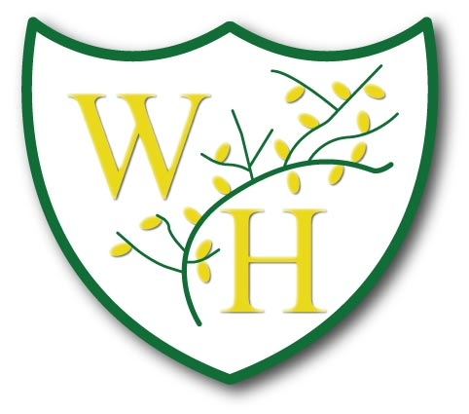

Key Vocabulary
Music
2022-2023
Key
Green Highlighted Text | Repeated twice
Red Highlighted Text | Repeated three times
Blue Highlighted Text | Repeated four times
Purple Highlighted Text | Repeated five or more times
Year 1
Autumn 1  Hey You | Autumn 2  Rhythm in the way we walk and The banana rap | Spring 1  ‘In the Groove’ | Spring 2  Round and Round | Summer 1  Your Imagination | Summer2  Reflect, Rewind and Replay
Pulse,  rhythm,  pitch,  compose  perform, | Pulse,  rhythm,  pitch,  rap,  singers,  perform, | Pulse,  rhythm,  pitch,  melody,  Blues,  singers,  groove,  perform, | Pulse,  rhythm,  pitch,  Latin,  Funk | Pulse,  rhythm,  pitch,  perform, percussion, trumpets, saxophones,  guitar, drums  audience,  imagination | Recap key vocabulary from previous teaching (Reflect, rewind and replay unit)
Year 2

Autumn 1  Hands, Feet Heart | Autumn 2  Ho ho ho | Spring 1  I wanna play in a band | Spring 2  Zootime | Summer 1  Friendship Song | Summer2  Reflect, Rewind and Replay
pulse,  rhythm,  pitch  melody,  dynamics,  tempo,  perform | pulse,  rhythm,  pitch  melody,  dynamics,  tempo, | pulse,  rhythm,  pitch  melody,  dynamics,  tempo,  audience,  improvise, compose,  perform  rap,  Keyboard,  drums,  bass, electric guitar, saxophone, trumpet, | pulse,  rhythm,  pitch  melody,  dynamics,  tempo,  audience, | pulse,  rhythm,  pitch  melody,  dynamics,  tempo,  audience,  improvise, compose,  glockenspiel,  drums  perform | Recap key vocabulary from previous teaching (Reflect, rewind and replay unit)
Year 3
Autumn 1  Let your Spirit Fly | Autumn 2  Glockenspiel Stage 1 | Spring 1  Three Little Birds | Spring 2  The Dragon Song | Summer 1  Bringing Us Together | Summer2  Reflect, Rewind and Replay
pulse,  rhythm,  pitch,  tempo,  dynamics, improvise, compose, bass, drums, guitar, keyboard,  verse,  chorus, | pulse,  rhythm,  pitch,  tempo,  dynamics,  melody, | pulse,  rhythm,  pitch,  tempo,  dynamics,  electric guitar, organ,  hook,  backing vocals,  Reggae,  verse,  chorus, | pulse,  rhythm,  pitch,  tempo,  dynamics,  backing vocals,  improvise, compose,  verse,  chorus, | pulse,  rhythm,  pitch,  tempo,  dynamics,  hook,  imagination, Disco | Recap key vocabulary from previous teaching (Reflect, rewind and replay unit)
Year 4
Autumn 1  Mama Mia | Autumn 2  Glockenspiel Stage 2 | Spring 1  Stop! | Spring 2  Lean On Me | Summer 1  Blackbird | Summer 2  Reflect, Rewind and Replay
pulse,  rhythm,  pitch,  tempo, dynamics, texture, structure,  solo,  Keyboard,  electric guitar,  improvise, compose, melody, improvise,  , rhythm patterns, lyrics, | pulse,  rhythm,  pitch,  tempo, dynamics, texture, structure,  notation,  rhythm patterns | pulse,  rhythm,  pitch,  tempo, dynamics, texture, structure,  improvise, compose, melody, improvise,  Keyboard, electric guitar  rhythm patterns | pulse,  rhythm,  pitch,  tempo, dynamics, texture, structure,  improvise, compose, melody, improvise,  lyrics,  rhythm patterns | pulse,  rhythm,  pitch,  tempo,  dynamics, texture,  structure,  solo  piano,  organ,  acoustic guitar, percussion, birdsong,  civil rights, racism,  equality.  rhythm patterns | Recap key vocabulary from previous teaching (Reflect, rewind and replay unit)
Year 5
Autumn 1  Living on a Prayer | Autumn 2  Classroom Jazz 1 | Spring 1  Make you feel my love | Spring 2  The Fresh Prince of Bel Air | Summer 1  Dancing in the Street | Summer 2  Reflect, Rewind and Replay
Rock,  bridge,  chorus,  pulse,  rhythm,  verse,  hook,  improvise,  pitch,  tempo,  dynamics,  timbre,  texture,  guitar,  drums,  melody, | pitch,  tempo, dynamics, timbre,  texture,  compose, appraising, Bossa Nova, syncopation, structure,  note names,  melody, | pitch, tempo, dynamics, timbre, texture,  bridge,  chorus,  pulse, rhythm,  solo, ballad, verse, interlude, ending, strings,  piano,  melody, | pitch, tempo, dynamics, timbre, texture,  hook,  improvise,  verse,  Old-school Hip Hop,  Rap,  backing loops,  melody, | pitch,  tempo,  dynamics,  timbre, texture,  bridge,  chorus,  pulse,  rhythm,  verse,  melody,  soul | Recap key vocabulary from previous teaching (Reflect, rewind and replay unit)
Year 6
Autumn 1  Happy | Autumn 2  Classroom Jazz 2 | Spring 1  A New Year Carol | Spring 2  You’ve got a Friend | Summer1  Music and Me | Summer 2  Reflect, Rewind and Replay
melody,  compose,  improvise,  cover,  pulse,  rhythm,  pitch,  tempo,  dynamics,  timbre,  texture,  producer,  groove,  hook,  riff,  solo | Blues,  Jazz  cover,  pulse,  rhythm,  pitch,  tempo,  dynamics,  timbre,  texture, | cover,  pulse,  rhythm,  pitch,  tempo,  dynamics,  timbre,  texture,  solo | cover,  pulse,  rhythm,  pitch,  tempo,  dynamics,  timbre,  texture,  melody,  compose,  improvise,  civil rights,  gender equality, unison,  solo | cover,  pulse,  rhythm,  pitch,  tempo,  dynamics,  timbre,  texture,  melody,  compose,  improvise,  civil rights,  gender equality, unison,  solo | Recap key vocabulary from previous teaching (Reflect, rewind and replay unit)

